**Name:** Sandeep Singh (2000534322) & Akshay Mali (2000271727)

**Command design pattern**

Command design pattern is one of the behavioral design patterns. In the command design pattern, an object is used for encapsulating all the information needed to perform an action or trigger an event at a later time. There are mainly 4 terms which is closely associated with command design pattern. These four terms are named as command, receiver, invoker and client. These four terms are dependent on each other.

Command – This command object knows about the “Receiver” and invokes a method of the receiver to instantiate the command type.

Receiver – This receiver object gets into action when the execute () method is command is called.

Invoker – The invoker object knows how to execute a command.

Client – The client object is used as a package. The command objects, invoker objects and receiver objects are stored in client object.

In our program, we have made a command interface where execute () method has been declared. We have used the command design pattern to create the users in the program. The execute function of the command interface has been called by the client object. The client object is responsible to create a new user in the store. Client object decides which commands to execute at which points. This command design pattern is completely working with the front controller and authorization pattern.

**UML is defined on next page for better understanding.**

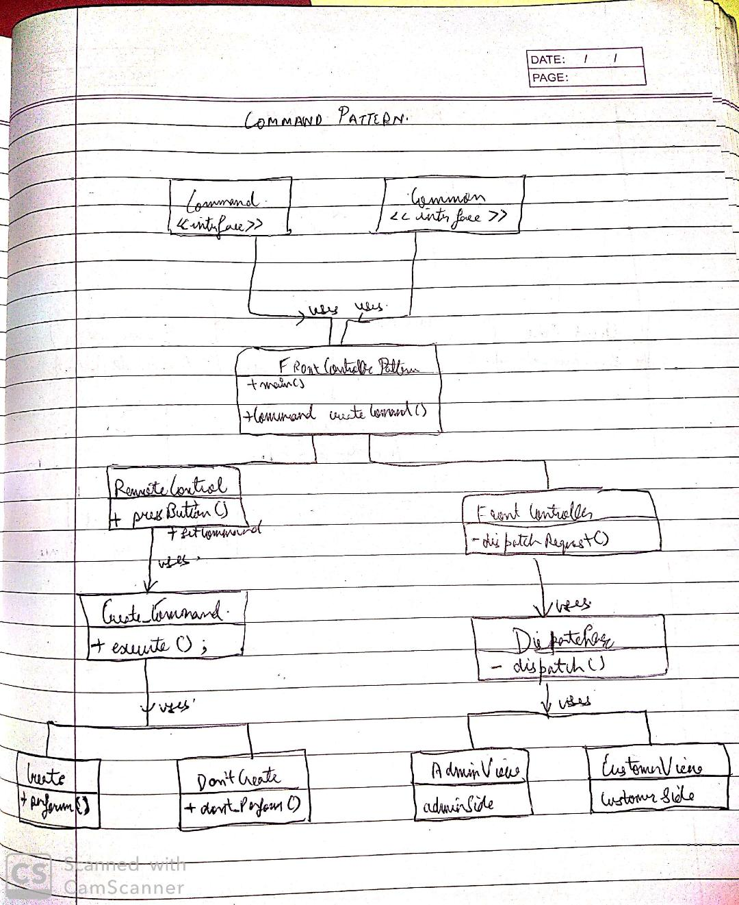

**SQL Database (Server Side Database Scripting)** –

In our program, we have created out SQL database and done the setting up that SQL database using MYSQL. We have written the SQL queries to create the different tables in the source file whose name is Store.sql. The tables created by SQL queries are user’s table and Product’s table. We have written the queries to fetch the data from the user’s tables and product’s table. We have shown that fetched data from database. Whenever a new user has been created, The information about the new user has been stored in the user’s table. The list in the user’s table has been updated after creating a new user.

DatabaseDisplay_User() – This method is used to display the information of the users stored in the user’s tables in the SQL Database. The required SQL query has been used to perform the given action in the method (Select Product).

DatabaseDisplay_Product() - This method is used to display the information of the users stored in the user’s tables in the SQL Database. The required SQL query has been used to perform the given action in the method (Select Product).

addProduct() – This method is used to add the newly created product in the database. The required SQL query has been used to perform the given action in the method (Insert Product).

updateProductQty() – After every shopping deal, required product quantity has been updated in the database by using this method. The required SQL query has been used to perform the given action in the method (Update Product Quantity).

updateProduct() – If there is any change in the product, them product information has been updated using this method. The required SQL query has been used to perform the given action in the method (Update Product).

removeProduct() – This method is used to remove the product from the database. The required SQL query has been used to perform the given action in the method (Delete Product).

removeUser() – This method is used to remove the user from the database. The required SQL query has been used to perform the given action in the method (Delete User).

addUser() – This method is used to add the user in the database. The required SQL query has been used to perform the given action in the method (Insert User).

addAdmin() – this method is used to add an admin in the database. The required SQL query has been used to perform the given action in the method (Insert Admin).

**UML is defined for better understanding.**

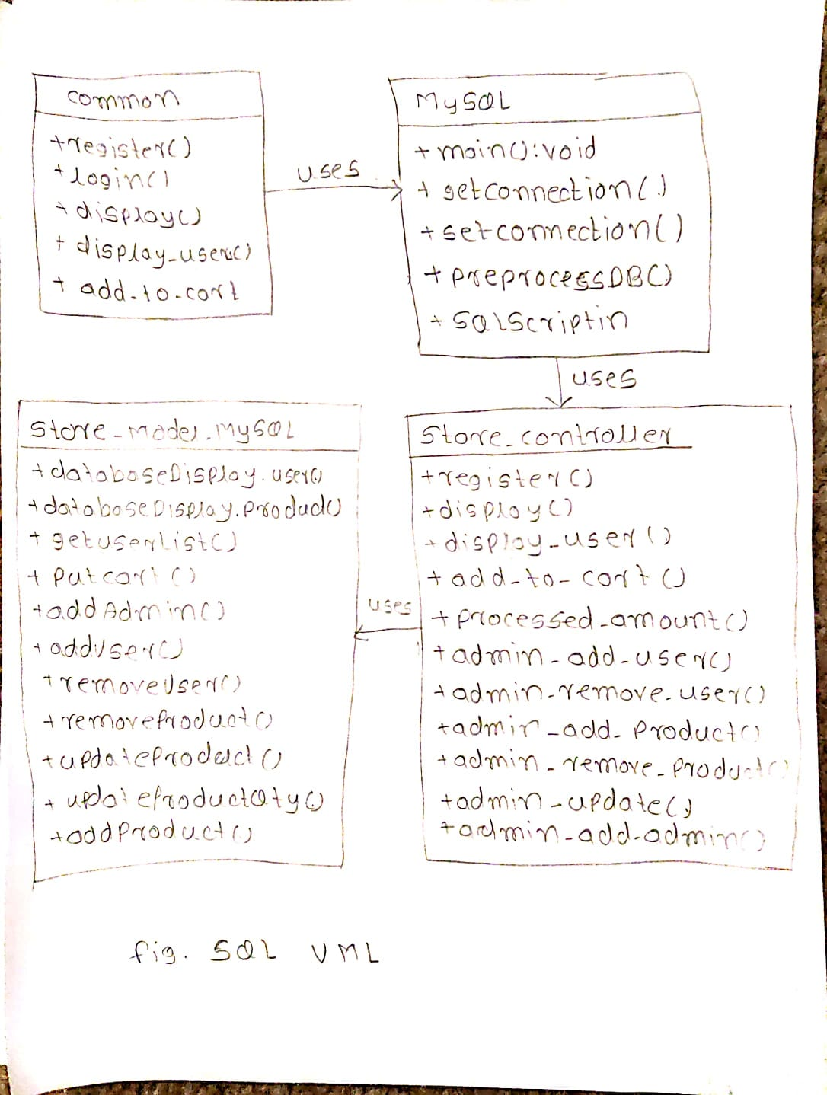

Abstract factory pattern –

The abstract factory [pattern](https://en.wikipedia.org/wiki/Software_design_pattern) provides a way to encapsulate a group of individual [factories](https://en.wikipedia.org/wiki/Factory_object) that have a common theme without specifying their concrete classes. In normal usage, the client software creates a concrete implementation of the abstract factory and then uses the generic [interface](https://en.wikipedia.org/wiki/Interface_(object-oriented_programming)) of the factory to create the concrete [objects](https://en.wikipedia.org/wiki/Object_(computer_science)) that are part of the theme. A factory is the location of a concrete class in the code at which [objects are constructed](https://en.wikipedia.org/wiki/Object_creation). The essence of the abstract factory pattern is to provide an interface for creating the families of related or dependent objects without specifying their concrete classes.

In our program, the abstract factory pattern is used to create the different products.

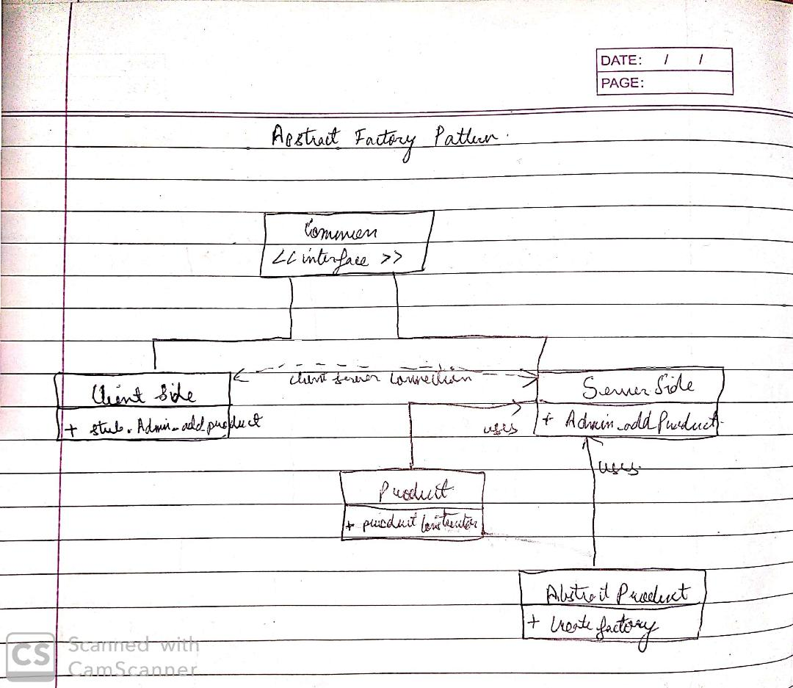

**Common Interface: The listed functions were implemented in main class.**

This package contains the interface. This interface contains the all the methods that are used in server as well as in client class. Methods like registering a new user, making the existing user to login to the system, displaying the list of products, adding the products in cart, processing the amount, adding and removing products.

Product Class –

This class is used to create the products.

User Class –

This class is used to create the user.

Common class{interface}

1. Boolean register(User user)throws RemoteException;

Returns a user object after registering for new user.

1. User login(User user)throws RemoteException;

Returns successful or unsuccessful message after the operation.

1. List<Product> display()throws RemoteException;

Returns the list of all the products.

1. List<User> display_users()throws RemoteException;

Returns the list of all the users.

1. List<Product> add_to_Cart(User user, int id, int quantity)throws Exception;

Returns the list of products that are added in the cart.

1. int processed_Amount(User user)throws Exception;

Returns the total amount of rates of products in the cart.

1. boolean admin_add_user(User user)throws RemoteException;

Returns the successful or unsuccessful message after addition of a new user by admin.

1. boolean admin_remove_user(String remove_email)throws RemoteException;

Returns the successful or unsuccessful message after removal of a user by admin.

1. boolean admin_add_product(String name, int amount, String type, int id, int price)throws RemoteException;

Returns the successful or unsuccessful message after addition of a new product by admin.

1. boolean admin_remove_product(int id)throws RemoteException;

Returns the successful or unsuccessful message after removal of a product by admin.

1. boolean admin_update(int id,int amount,int price)throws RemoteException;

Returns the successful or unsuccessful message for the updation in price.

1. boolean admin_add_admin(String name,String email,String password , boolean isAdmin)throws RemoteException;

Returns the successful or unsuccessful message for the adding an admin.

**Command Interface**

It contains the execute () method which is abstract and is implemented in all the classes in which this interface is inherited.

**Client: FrontControllerPattern**

Front Controller is implemented where there is a front controller class that dispatches the request if it’s authentic to either Admin view or Customer view with the help of Dispatcher.

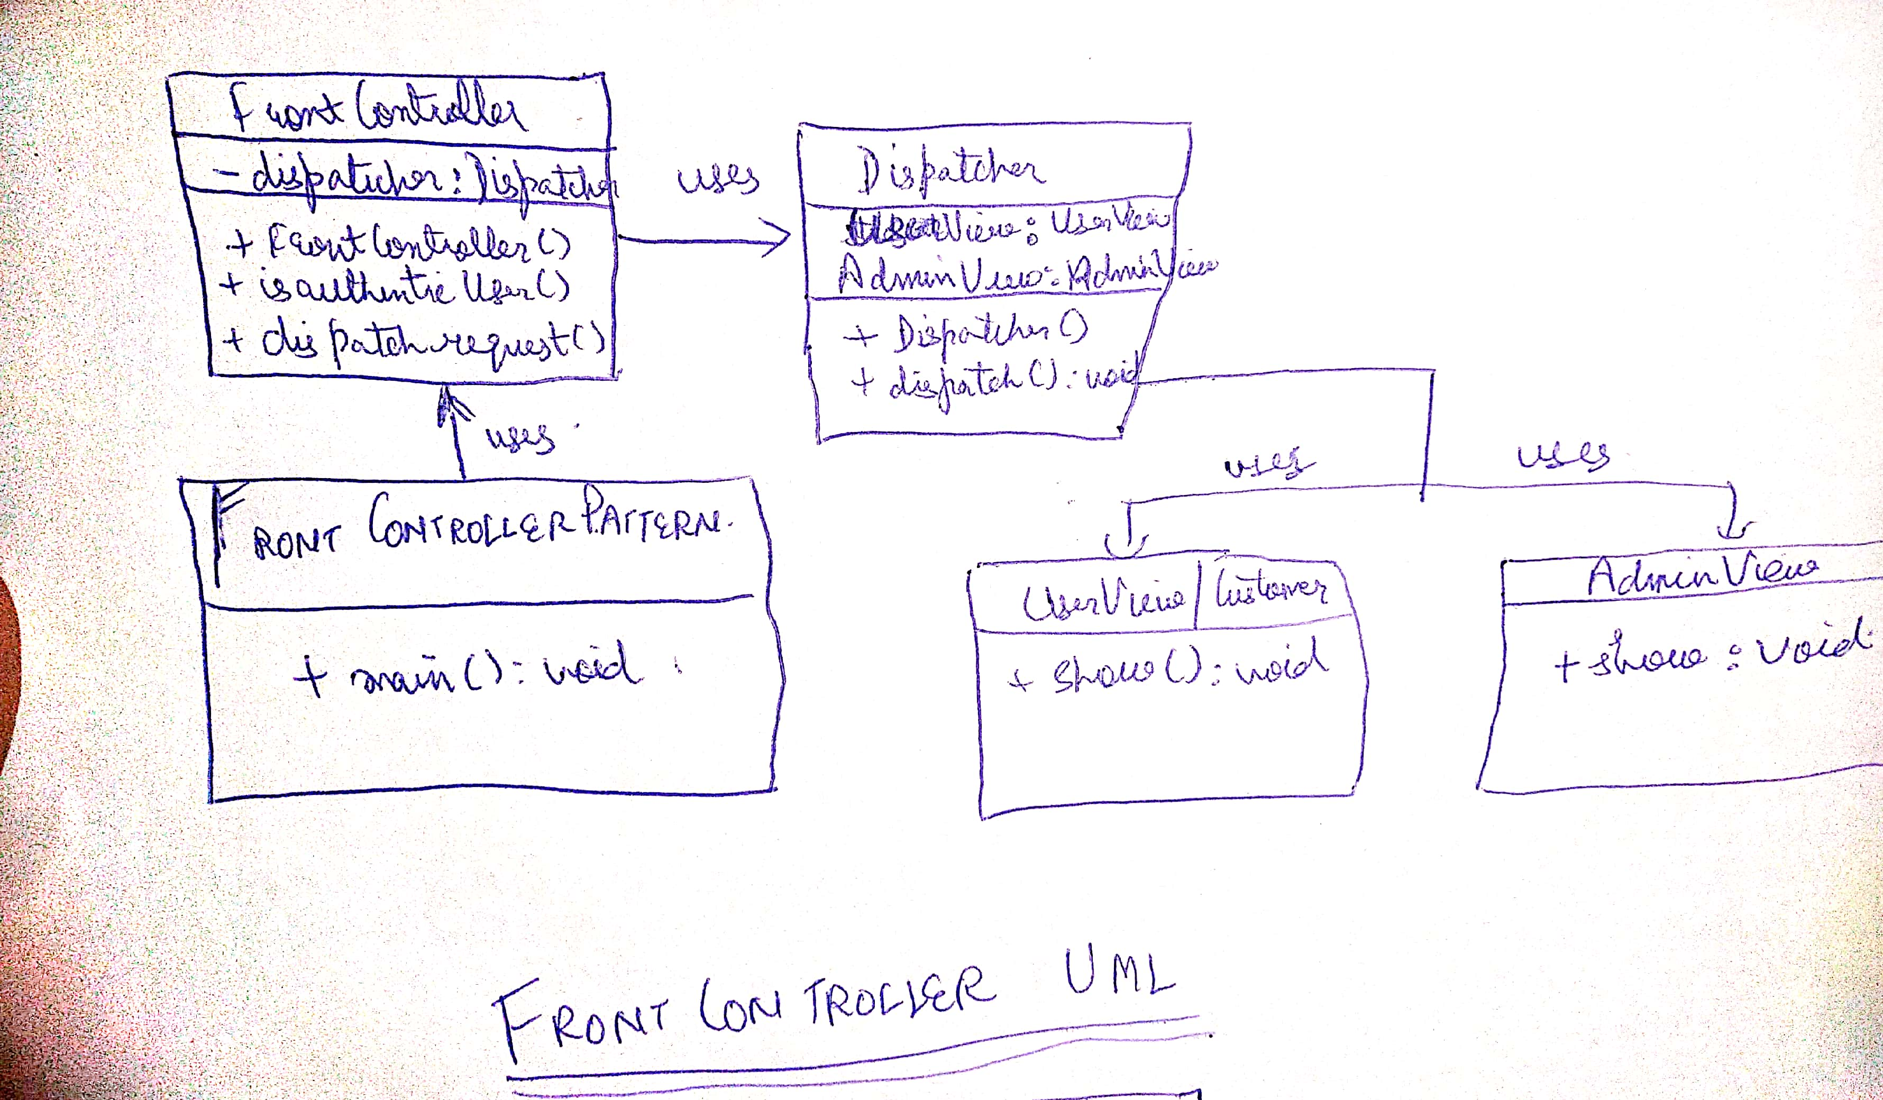

We have made a class named client. This class is used to call the different methods in the project. This class is responsible to handle the methods which are used for login process and shopping related process. This class is used to display the different successful and unsuccessful messages.

Behavior of the pattern–

After running this class, it gives 2 options at start like register a new user or login for existing user. If option 1 has been selected then it registers a new user. . If option 2 has been selected, then existing users need to put the email and password. If the username and password is correct the it will allow users to login into the system. If the username and password is not correct then system will throw the exception. If the user logged in as admin then system gives 7 options for adding and removing a user, adding and removing a product, updating the prize of a specific product and adding an admin. If user logged in as regular user, then it gives users to select the products to buy and add into the cart so that they can check out with final prize amount shown on the terminal.

**Server:**

Following classes and functions are used at server.

Store Class –

This class implements all the methods of the common interface and computes the values and performs functions .This class is used to do multiple tasks at server. These tasks include creation of products, creation of users, addition of products, removal of products and addition and removal of products in cart. The most important task of this class is to send information of products to the client.

